1. First insert table and select a cell within the table

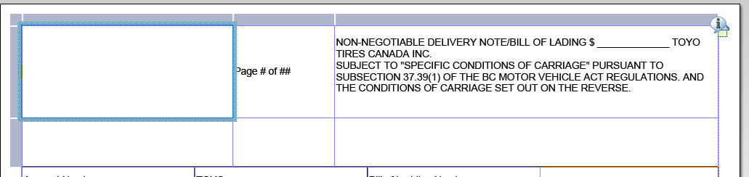

1. Then insert a table within

